**[Mapping Stored Procedure Parameters in SSIS OLE DB Source Editor](http://geekswithblogs.net/stun/archive/2009/03/05/mapping-stored-procedure-parameters-in-ssis-ole-db-source-editor.aspx" \o "Title of this entry.)**

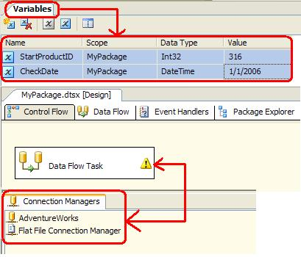

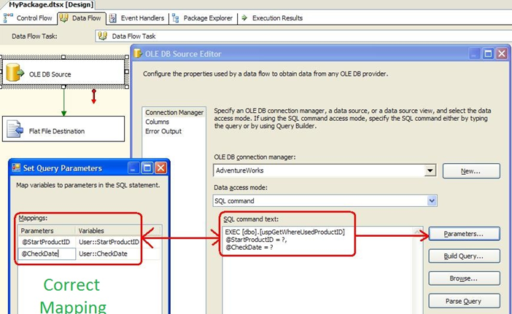

The order in which the parameters appear in the **Mappings** list is irrelevant.

The only requirement is that the parameter names match the variable names in the stored procedure, including the @ sign. @StartProductID = ?

**Incorrect:** EXEC [dbo].[uspGetWhereUserProduct] ?, ?

**Correct:** EXEC [dbo].[uspGetWhereUserProduct] @StartProductID = ?, @CheckDate=?

If you use the incorrect statement you will receive:

The SQL command requires a parameter named "@ParameterName", which is not found in the parameter mapping.  
component "OLE DB Source" (1) failed the pre-execute phase and returned error code 0xC0207014.